**STEPS TO CONNECT TO IBM WATSON IOT PLATFORM AND CREATE A DEVICE**

1. Sign up for IBM Academic Initiative Account

Go to this link

<https://my15.digitalexperience.ibm.com/b73a5759-c6a6-4033-ab6b-d9d4f9a6d65b/dxsites/151914d1-03d2-48fe-97d9-d21166848e65/home/>

1. Sign up for IBM Cloud

Go to this link

<https://cloud.ibm.com/login>

1. Go to IBM Watson IOT Platform by searching IOT platform in the catalogue in IBM Cloud

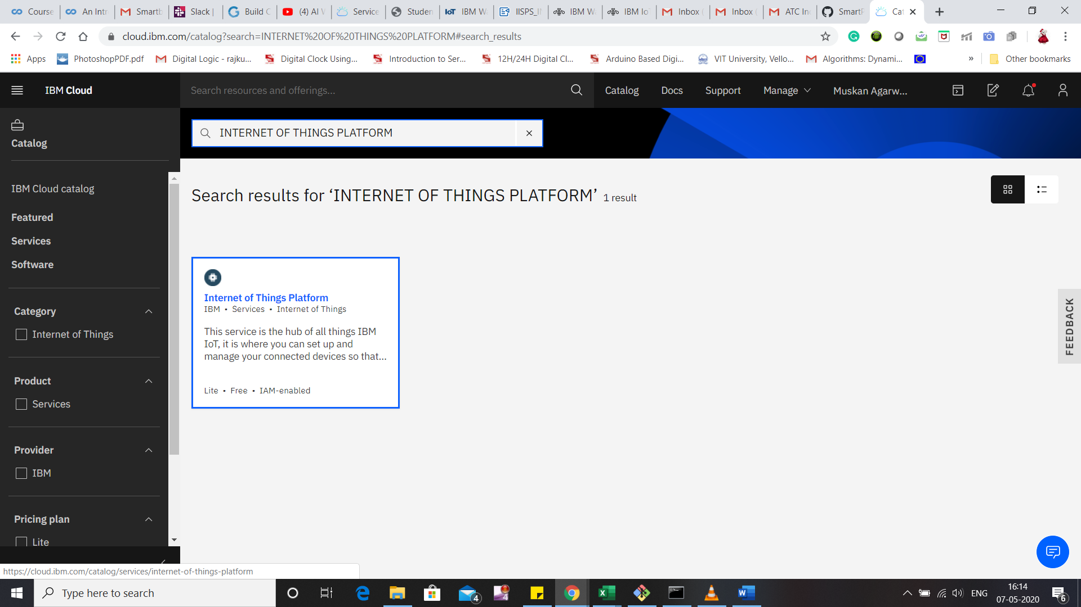

1. Go to the IOT Platform and now we will create a device here.

Follow Step 6 on this link to create a device

1. You will get Device credentials save them so that we connect to IOT simulator

Go to link for IOT simulator

<https://watson-iot-sensor-simulator.mybluemix.net/>

1. Link for steps to install Nod-Red in windows

<https://nodered.org/docs/getting-started/windows#3-run-node-red>